FOREIGN TRADE UNIVERSITY HCMC CAMPUS

---------o0o---------


Final Assignment
TCHE322 – Fin1
Lecturer: Ms. Dang Le Phuong Xuan
Name of student: Đổ Thị Mỹ Huyền
Student ID: 2312345024
Email: k62.2312345024@ftu.edu.vn
Grade (in number) | Grade (in words)

Ho Chi Minh City, 18th June, 2025

SECTION 0: KEY ASSUMPTIONS 2
SECTION 1: BACKGROUND INFORMATION 3
I. Huyen’s background 3
II. Huyen’s family financial goals 3
1. Short term goals 3
2. Intermediate goals 4
2.1. Promotion to highest position in the bank’s branch 4
2.2. Child living expense 4
2.3. Home mortgage payment 4
2.4. Car payment 5
2.5. Insurance 5
3. Long term goals 5
SECTION 3: ASSESSMENT FINANCIAL SITUATION 6
1. Salary 6
2. Traditional Balance Sheet 7
3. Economic Balance Sheet 7
4. Cash Flow statement 8
5. Budget statement 9
SECTION 4: RISK MANAGEMENT 10
1. Risk identification 10
2. Risk management plan 11
3. Insurance comparison 11
a. Life insurance 11
b. Health insurance 12
c. Car insurance 12
d. Motorbike insurance 13
SECTION 5: INVESTMENT 13
1. Asset allocation 13
2. Market return 14
3. Risk tolerance 15
4. Monte Carlo 15
SECTION 6: ECONOMIC ANALYSIS 16
1. Global events 16
2. Political events 16
SECTION 7: CONCLUSION 17
APPENDIX 20
Appendix 1A: Sun Life’s Life insurance 20
Appendix 1B: Prudential’s Life insurance 22
Appendix 1C: Bao Viet’s Life insurance 23
Appendix 2: Health insurance comparison 24

SECTION 0: KEY ASSUMPTIONS

Assumption | Reasons
Huyen: Bank Teller. Huyen's husband: Recruitment Assistant. | Huyen works in the financial industry.
The applicable mortgage and saving rate will remain stable. | The applicable rates are the average of 13 banks in Vietnam.
Annual living expenses increase with inflation rate. | We do not change our lifestyle.
Using inflation rate as annual salary growth rate. | We will not change the career path.
Vietnam's 30 year bond yield is fixed through the calculated period. | Vietnam's 30 year bond yield serves as the risk-free rate.
Huyen and Huyen's husband retire, regulated by a new law. Specifically, Huyen retires at 60 and Huyen's husband retires at 62. Both retire at the end of that year. | Based on Decree 135/2020 ND-CP.
We marry at the end of year 2025 at all parent cost. | Our parents will support our wedding.
Insurance premiums are fixed during the contract period. | Most insurance contracts promise fixed premiums.
We buy life insurance when we turn 30 years old. | We hedge against premature death risk during the working period.
Our child will become independent when he turns 22 years old. | He can take responsibility for his life.
Travel in Asia, Europe, Australia and Africa. | We fulfill our dream to travel around the world.
Both will die at the end of the year 2088. | Our life expectancy is both 85 years old.

SECTION 1: BACKGROUND INFORMATION

Huyen’s background
My name is Huyen. I just turn 22 years old, single and working in the financial industry. I live in a rented one-bedroom apartment. The only source of my income now is from my employment as a bank teller. I earn 179 million VND annually from my employment. All my assets are tangible assets, including an iphone, ipad, macbook and a motorbike.

Huyen’s family financial goals

Short term goals
My short term goal is to get married at the end of the year 2025 and establish a financial foundation. I will focus on building my career to achieve a promotion to an executive team and ensure financial stability to cover all expenses and start saving and investing.

Intermediate goals
The intermediate goal is to build strategic wealth growth and accumulation. Our family plans to buy a house, buy a car and raise the child until he becomes independent.

2.1. Promotion to highest position in the bank’s branch
My first position entering the executive team is Deputy Head of Customer Service. After working in this position for three years, I will get promoted to Head of Customer Service. For the next three years, I will work as Deputy Director of Operations. For the remaining years, I will become Branch manager. I will work in this position until I retire.

2.2. Child living expense
The child will be born in 2030 when Huyen becomes Deputy Head of Customer Service. Living expenses of the child including basic needs, medical cost, derivative cost and education until university. The expenses will depend on the child’s age. They are high when the child is born and when he enters university.

2.3. Home mortgage payment
We plan to buy a house in the next ten years when Huyen is promoted to Head of customer service department. The home mortgage loan of nearly 3,2 billion VND is structured to last for 10 years, beginning from 2035 to 2044. According to VPBank (2024), a 10-year mortgage is an ideal option to have a house without the accumulation of a big amount of money. The table below shows the interest rate for mortgages by 13 banks in Vietnam (VPBank, 2025).
Table 1: Interest rate for mortgage in 2025.
No | Bank's Name | Applicable Interest Rate
1 | BIDV | 5.00%
2 | Vietcombank | 5.50%
3 | Agribank | 6.00%
4 | Vietinbank | 6.00%
5 | VIB | 6.50%
6 | Techcombank | 6.70%
7 | VPBank | 7.20%
8 | TPBank | 6.60%
9 | ACB | 7.00%
10 | Sacombank | 7.00%
11 | MSB | 6.20%
12 | HDBank | 6.50%
13 | MBBank | 7.90%
Average |  | 6.47%
With the applicable interest rate assumed at 6.47% and term payment is 10 years, our family will pay a fixed payment of 450 million VND per year.

2.4. Car payment
We plan to buy a Toyota Vios 4-seat car with one-time payment in 2048 when the child enters university. This is because we want to have a more convenient means of transport which can carry the whole family. Another reason is that we want to fulfill all wants before the child becomes independent. After he becomes independent, we will accumulate wealth to achieve our long term goals.

2.5. Insurance
My husband and I are both breadwinners of the family. Therefore, unforeseen events such as health problems or premature death may hurt the financial health of the family. In order to protect the family’s health and avoid financial hardship, we consider health insurance for the whole family and a life insurance package that protects both breadwinners.

Long term goals
Our long term goals are to enjoy a secured and worry-free retirement in which we can travel around the world and live the lifestyle we want. Apart from pension value, we also get interest from saving and bond fund investment to ensure a durable cash inflow.

SECTION 3: ASSESSMENT FINANCIAL SITUATION

Salary
Table 2: Huyen’s salary
Age | Position | Yearly salary (with bonus)
22 - 24 | Bank teller | 179 - 189 million VND
25-26 | Promotion to Controller | 228 - 235 million VND
27-30 | Promotion to Deputy Head of Customer Service | 260 - 283 million VND
31-33 | Promotion to Head of Customer Service | 325 - 343 million VND
34-36 | Promotion to Deputy Director of Operations | 520 - 550 million VND
37 - 60 | Promotion to Branch manager | 910 - 1748 million VND
Table 2 is Huyen’s salary and career path. The salary is adjusted to the annual salary growth rate.
Table 3: Inflation rate
Inflation Rate
Year | Rate
2025 | 2.95%
2026 | 2.49%
2027 | 2.80%
2028 | 2.90%
2029 | 2.90%
2030 | 2.90%
2030 Afterwards | 2.88%
We assume the annual salary growth rate is equal to the inflation rate of that year. The annual salary growth rate for each sector and each position are varied because it depends on each company, the expertise and degree of each employee. Therefore, we use inflation rate as the minimum salary growth rate for our occupation.

Traditional Balance Sheet
Table 4: Traditional balance sheet
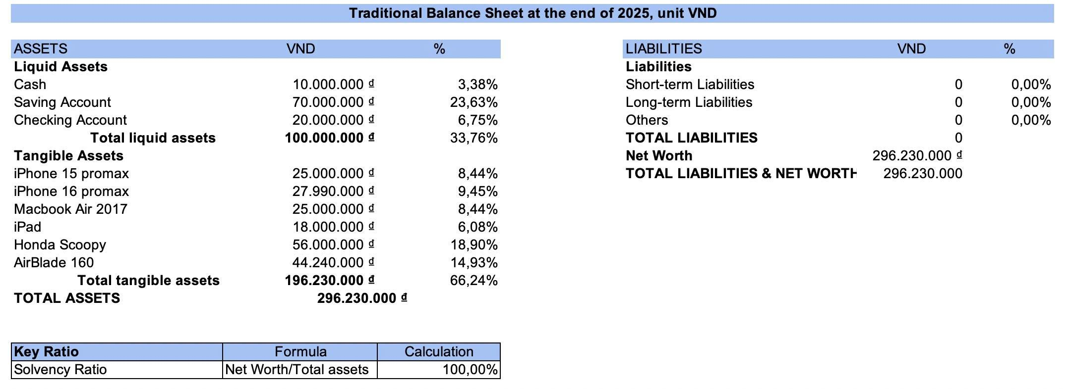

The traditional balance sheet reports assets, liabilities and net worth. It provides an outline of what the family owns and owes, as well as the amount of wealth at a specific point (Investopedia, 2025). The family’s total assets is 296,230 million VND, with 33.76% of liquid assets and 66.24% of tangible assets. At the end of the year 2025, the family accumulates no liabilities.
Total net worth is 296,230 million VND combined with total assets of 296,230 million VND resulting in 100% in solvency ratio. The high solvency ratio implies the family’s financial stability (CFI. n.d).

Economic Balance Sheet
Table 5: Economic balance sheet
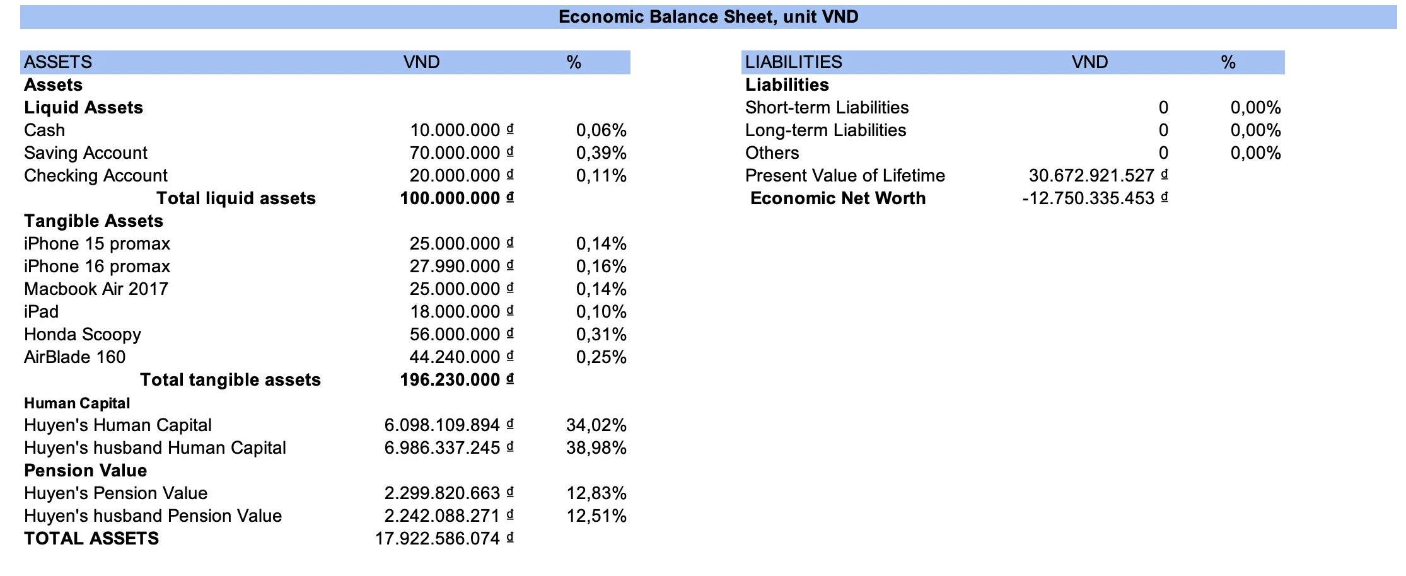
Unlike traditional balance sheets, the economic balance sheet goes beyond physical components and includes intangible assets (AnalystPrep, 2024). By adding intangible assets such as human capital and pension value, total assets is nearly 18 billion VND. Negative economic net worth suggests human capital and pension value are unable to cover lifetime consumption needs and propose an investment plan (CFI Institute, 2025) and establish an emergency fund.

Cash Flow statement
Table 6: Cash flow statement
Cash Flow Statement for the family at the end of 2025
Income | VND | %
Huyen's gross salary | 179,400,000 ₫ | 47.42%
Huyen's husband gross salary | 195,000,000 ₫ | 51.54%
Interest | 3,920,000 ₫ | 1.04%
TOTAL INCOME | 378,320,000 ₫
Expenses
Living expense | 374,388,000 ₫ | 100.00%
TOTAL EXPENSE | 374,388,000 ₫
Surplus/Deficit | 3,932,000 ₫
The cash flow statement outlines how much cash comes in and out over a certain period (Investopedia, 2025). The main sources of income is from my and my husband's salary, and with a small amount of interest from saving and investment. Total yearly expense of 374 million VND results in a surplus of 3,932 million VND.

Budget statement
Table 7: Budget statement before retirement
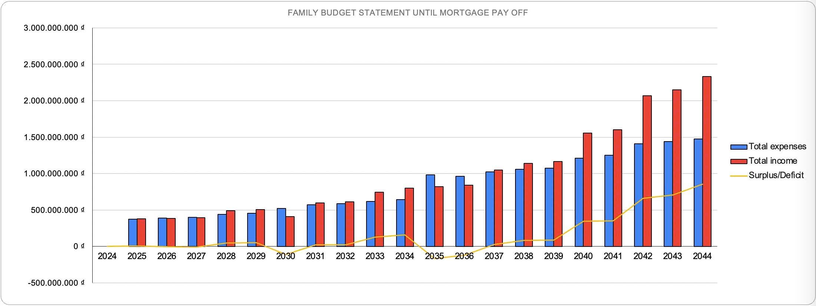
The budgeting statement estimates income and expenses for the year and specified period (Indeed, 2025). Before retirement, total salary has sustainable growth except for the year 2030, when Huyen leaves for a 6 month maternity period. A big deficit starting in 2035 is when we start paying for mortgage loan. From 2037, surplus happens again when total salary increases.
Table 8: Budget statement after retirement
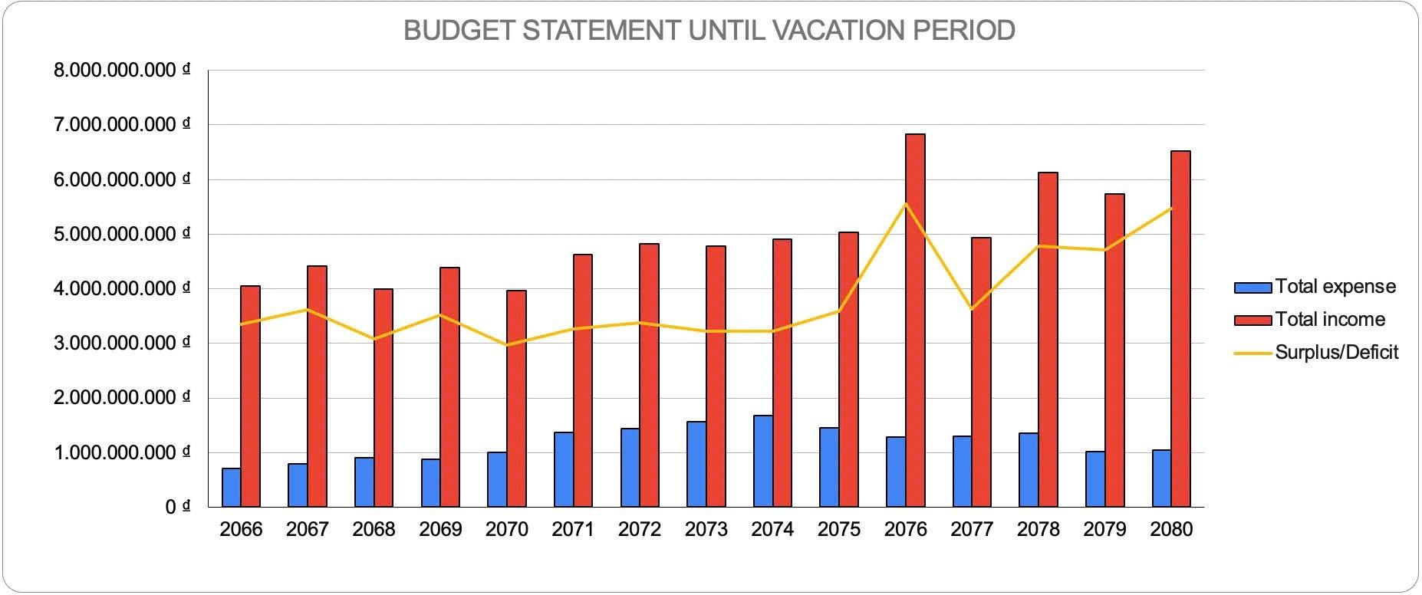
After retirement, total salary also witnesses a high growth but fluctuation in some years due to stable pension and high but fluctuated return from investment. After we fulfill our goal to travel around the world in 2078, the total expenses decline slightly but they are still at a high level. High surplus at the end of each year means that we enjoy worry-free retirement and live the lifestyle we want.

SECTION 4: RISK MANAGEMENT

Risk identification
Table 9: Three risks identification
Risk | Situation | Dealing method
Earning Risk | - Huyen and husband’s earning risks: loss of earning and human capital due to unemployment (AnalystPrep, 2023). | - Risk Reduction: Pay social insurance  - Risk Retention: Saving
Premature death Risk | - Huyen or husband's untimely death: hurt the source of income for the family (AnalystPrep, 2023). | - Risk Reduction: Avoid risky human activities  - Risk Transfer: Buy Life Insurance  - Risk Retention: Saving
Health Risk | - Health Risk: affects the whole family and burdens medical bills (AnalystPrep, 2023). | - Risk Reduction: Have a healthy lifestyle  - Risk Transfer: Buy health insurance  - Risk Retention: Saving
These three risks are related to earning risk, which can cause a big loss for the financial health of the family. As Huyen and her husband are both breadwinners, therefore, life insurance can protect both of us. With health risk, health problems make the family suffer from unexpected and burdensome medical expenses. Therefore, health insurance can relieve the family medical burden.

Risk management plan
Table 10: Risk management plan for 3 risks
Risk | Method Chosen | Action Plan
Earning Risk | Risk Transfer and Risk Retention | - Pay Social Obligations  - Saving frequently
Premature death Risk | Risk Transfer | - Buy Life insurance
Health Risk | Risk Transfer | - Buy Health insurance
Paying social insurance and having an emergency fund help the family maintain living standards during unemployment. Buying life insurance will protect both breadwinners, while health insurance will support medical costs in case of health problems.

Insurance comparison

Life insurance
Table 11: Life insurance comparison
Life Insurance Comparison
Characteristics | Sun Life - Sun Sống Mới | Prudential - Phú Bảo An | Bảo Việt - An Phát Trọn Đời
Coverage Aspects | Medium | Highest | Medium
Uncoverage Aspects | Highest | Medium | Lowest
Total Fees | Medium | Lowest | Medium
Selection Life Insurance Package |  |  | Prudential
Prudential - Phu Bao An is the most comprehensive life insurance package. It covers benefits for both breadwinners in case of Death and Permanent Total Disability, Fatal diseases and medical costs due to accidents. The premium is 10,900 million VND and is fixed during the contract period of 30 years. With the Death benefit, it covers 100% of the insurance amount. With Permanent Total Disability, it covers 10% of insurance amount/year x 10 years.

Health insurance
Table 12: Health insurance comparison
Health Insurance Comparison
Characteristics | Bảo Việt An Gia | PVI | PJICO
Coverage Aspects | Medium | Highest | Medium
Uncoverage Aspects | Highest | Lowest | Highest
Total Fees | Highest | Lowest | Medium
Selection Health Insurance Package |  |  | PVI Care
PVI Care is the most comprehensive health insurance plan. Its main benefits include accident insurance and inpatient treatment for illness, sickness, and maternity. Its other benefits include costs before hospitalization, within 30 days, home healthcare medical expenses after hospital discharge, and funeral allowance if death occurs in hospital. Some of the insurance’s supplemental health benefits are outpatient treatment in case of illness, sickness, or accident, dental insurance, maternity, and life insurance due to illness or sickness. Bao Viet has the highest uncoverage aspects and highest fee, while PIJCO focuses on inpatient care. PVI has the highest coverage aspects with lowest fee, therefore, choosing PVI.

Car insurance
Table 13: Car insurance comparison
Car Insurance Comparison
Characteristics | PVI | Bảo Việt | PJICO
Coverage Aspects | Same | Same | Same
Uncoverage Aspects | Same | Same | Same
Fees for owner’s civil liability | Same | Same | Same
Fees for physical damage | Highest | Medium | Lowest
Fees for people staying in a car | Lowest | Lowest | Highest
Total Fees | Highest | Medium | Lowest
Selection Car Insurance |  |  | PJICO
Owner’s civil liability insurance is compulsory when buying a car and this premium is fixed throughout the usage period (Giaxeoto, 2025). Physical damage insurance and insurance for people staying in a car are optional. Physical damage insurance fee is based on the remaining value of the car and fee rate (Giaxeoto, 2025). Based on the calculation, PJICO has the lowest price, therefore, choosing PJICO for the family.

Motorbike insurance
Table 14: Motorbike insurance comparison
Motorbike Insurance Comparison
Characteristics | PVI | Bảo Việt
Coverage Aspects | Same | Same
Uncoverage Aspects | Same | Same
Fees | Same | Same
Motorbike insurance is compulsory for traffic participants (Thu vien phap luat, 2025). It includes motorbike fire and explosion insurance, compulsory motor vehicle owner's civil liability insurance and passenger accident insurance. This insurance is not much different between companies, the premium is all at 66,000 VND.

SECTION 5: INVESTMENT

Asset allocation
Table 15: Three fund types
Fund Type | Description
Emergency Fund | Cover unexpected shortfall in income.
Saving Fund | Store for future consumption.
Investment Fund | Used for investments.

Our family has three types of funds: emergency fund, saving fund, and investment fund. Emergency fund covers unexpected shortfall in income and it is stored in the checking account. The desired balance will be half of yearly expense as minimum living standard. The saving fund is used to save for future needs and stored in the savings account. Investment fund is used to invest in stock and bond fund DCBF.
When deficits occur, we prioritise withdrawal order from the emergency fund, saving fund and investment fund. The emergency fund is the most liquid and earns no interest. While the saving fund and investment fund are less liquid as they can only be withdrawn until maturity.
When surplus occurs, we will first add this surplus amount to the emergency fund to make the current amount equal to the desired amount. The surplus left will be added to the saving fund and investment fund based on the rule 60 - 20 - 20. 60% of surplus left will be added to the saving fund, 20% will be invested in stock and 20% will be invested in the bond fund.

Market return
Table 16: Characteristics of some instruments
Instruments | Characteristics
Stock | Highly liquid, high returns, high market risk.
Bond | Periodic payment, lower returns, lower risk.
DCBF | A diversified portfolio of assets, offering high liquidity.
Gold | Value influenced by supply and demand.
Crypto | High returns, high risks.

We choose to invest only in stock and the bond fund because of their high liquidity and high return among the instruments above. Secondary market for bonds in Vietnam is developing but only a small amount of bonds are frequently traded in this market. This makes it difficult to determine the actual market value (FiinGroup, 2025). Gold market is influenced by the global economy, politics, inflation, interest rate, supply and demand for gold. Therefore the gold value can fluctuate in the short run (ACB, 2025). Crypto market is risky because the legal framework for digital currencies in Vietnam is incomplete (Dien dan Doanh Nghiep, 2024).

Risk tolerance
Morin and Suarez (1983) showed that risk aversion increased with age. Before we have a child, we take high risk for high return. We have 20% in stock and 20% in the bond fund. After having the child, in order to ensure durable cash inflow from investment to raise the child, buy the house and car, we redistribute our investment portfolio to have 10% in stock and 30% in bond fund. According to Ibbotson Associates (1997), stocks offer a higher return than less volatile investments such as Treasury bills. However, Malkiel (1996) suggested that when approaching retirement, the proportion of a portfolio devoted to stocks should decrease. As we approach retirement, we have 5% in stock. This amount decreases to 0% as we retire.

Monte Carlo
Table 17: Monte Carlo result
Retirement Expense | -78,997,474,721 ₫
Average | 58,816,668,512 ₫
Volatility | 2150042190
25th Percentile | 57,369,217,673 ₫
50th Percentile | 58,766,801,657 ₫
75th Percentile | 60,212,179,847 ₫
95th Percentile | 62,438,001,547 ₫
Prob(Successful) | 100.00%

Negative economic net worth in the economic balance sheet suggests human capital and pension value are unable to cover our lifetime consumption needs and propose an investment plan. After running Monte Carlo simulation, we have a probability of 100%, which means we are successful in investment to enjoy worry-free retirement.

SECTION 6: ECONOMIC ANALYSIS

Global events
In addition to the geopolitical tension between Israel and Iran, inflation concerns in the US, the market is also affected by trade conflicts due to US tariff policies, leading to concerns about a slowdown in global economic growth (Bao Quan doi nhan dan, 2025). Rong Viet Securities predicted that global stocks may experience significant volatility similar to that of 2018 (VnEconomy, 2025). But the downward trend of the Vietnam stock market is predicted to be low due to market valuation and growth prospects. The likelihood of tariffs being imposed on Vietnam in 2025 is low and Vietnam can benefit from competition among big countries (VnEconomy, 2025). In the middle of June, VN-INDEX’s strongest increase in two months (VnExpress, 2025), is a positive sign for our family to invest in the stock market for high return.
The FED announcement of unchanged interest rates and prediction of increasing inflation and unemployment, along with the situation in Vietnam where the restructuring of the state administrative apparatus will increase government spending and impact consumer prices (Bao Quan doi nhan dan, 2025), create inflationary pressures and devalue the VND. Increasing consumer prices will erode purchasing power and make it difficult for our family to maintain insurance premiums payment.

Political events
The tense global politics can affect oil, gold or commodity prices across the world (Bao dien tu Tien Phong, 2025). Vietnam continues attracting FDI inflow despite global situations, demonstrating investor confidence in the country’s investment climate (Thoi Bao Tai Chinh, 2025). FDI inflows bring technological progress and increase employment in developing countries. This results in an increase in the production of goods and GDP. Economic growth is a positive for the development of stock markets and the rise of share prices (Rajapake, 2018). FDI policy changes the insurance sector by driving innovation, increasing competition and improving access to insurance products (Rawat and Saini, 2024). The foreign participation leads to severe competition, better pricing, improved customer service and a wide range of product offerings in the insurance market.

SECTION 7: CONCLUSION
In conclusion, our family achieves short, intermediate and long term goals. In the short term, we build a strong financial foundation because we both get promoted to higher positions to enter the executive team. We also start saving and investing. In the intermediate term, we achieve our goals including having a child, buying a house and a car. Although we have deficits in some years when we have the child and pay off the mortgage loan, we still have the emergency fund to cover. The saving and investment fund still offer high returns through years. In the long term, we enjoy secured retirement and travel around the world due to stable pension and high interest return. To cover premature death or health risk, our family should buy health insurance package PVI Care for whole family members and the life insurance package Prudential - Phu Bao An which can protect both breadwinners. In case of economic or political changes, in order to hedge against stock market fluctuations, our family should maintain 60% in the savings account, 20% in stock and 20% in the bond fund. 60% in the savings account will remain fixed during our life expectancy, while the percentage of stock or the bond fund will change as we approach retirement and death. Limits of our plan include not considering having the second child, the volatility of occupation and inheritance for the child.
REFERENCE
AnalystPrep. (2023). The individual balance sheet. Available at: https://analystprep.com/study-notes/cfa-level-iii/the-individual-balance-sheet/
AnalystPrep. (2025). Individuals' risk exposures. Available at: https://analystprep.com/study-notes/cfa-level-iii/individuals-risk-exposures/
Báo Lao Động. (2023). Khép lại 2022 đắng lòng chứng sĩ, chứng khoán 2023 dự báo khấm khá. Báo Lao Động. Available at: https://laodong.vn/tien-te-dau-tu/khep-lai-2022-dang-long-chung-si-chung-khoan-2023-du-bao-kham-kha-1133591.ldo
Báo Quân đội nhân dân. (2025). Giá vàng chiều nay (16-6): Tăng mạnh giá mua vào. Available at: https://www.qdnd.vn/kinh-te/tin-tuc/gia-vang-chieu-nay-16-6-tang-manh-gia-mua-vao-833022
Báo Quân đội nhân dân. (2025). Lạm phát tại Việt Nam năm 2025: Nhiều áp lực. Retrieved from: https://www.qdnd.vn/kinh-te/cac-van-de/lam-phat-tai-viet-nam-nam-2025-nhieu-ap-luc-811226
CafeF. (n.d.). Lãi suất ngân hàng. Available at: https://cafef.vn/du-lieu/lai-suat-ngan-hang.chn
CFA Institute. (2025). Net worth optimization: A new era of personalized risk optimization. Available at: https://blogs.cfainstitute.org/investor/2025/03/25/net-worth-optimization-a-new-era-of-personalized-risk-optimization/
Corporate Finance Institute. (n.d.). Solvency ratio. Available at: https://corporatefinanceinstitute.com/resources/commercial-lending/solvency-ratio
Diễn Đàn Doanh Nghiệp. (2024). Nhà đầu tư thận trọng khi đầu tư vào tiền số. Available at: https://diendandoanhnghiep.vn/nha-dau-tu-than-trong-khi-dau-tu-vao-tien-so-10146165.html
FiinGroup. (2025, April 15). Giá Trị Rõ Ràng - Đầu Tư An Toàn với Bond Pricing - Dịch vụ Tính Giá Trái Phiếu Dựa Trên Dữ Liệu. Available at: https://fiingroup.vn/NewsInsights/Detail/11567524?lang=vi-vn
Ibbotson Associates (1997). Stocks, Bonds, Bill, and Inflation. 1997 Yearbook. Chicago: Ibbotson Associates.
ICMIF. (2024). Holistic balance sheet management in insurance: Navigating the path from risk-taking to value creation. Available at: https://www.icmif.org/blog_articles/holistic-balance-sheet-management-in-insurance-navigating-the-patch-from-risk-taking-to-value-creation/
Malkiel, B. G. (1996). A Random Walk Down Wall Street. New York: W. W. Norton & Co.
Morin, R. A. & Suarez, A. F. (1983). Risk aversion revisited. The TournoLof Hinance 38(4) 1201-1216.
Rajapakse, R. P. C. R. (2018). The Relationship Between the Stock Market and Foreign Direct Investment (FDI) in Sri Lanka-Evidence from VAR and Co-Integration Analysis. Global Journal of Management and Business Research: B Economics and Commerce Volume 18. Available at SSRN: https://ssrn.com/abstract=3231665
Rawat, Richa Saini. (2024). Unpacking the Effects of Revised FDI Policy on India's Life Insurance: Through the Lens of Profits/(Loss) and Equity. Available at SSRN: https://ssrn.com/abstract=4889413 or http://dx.doi.org/10.2139/ssrn.4889413
Thời báo Tài chính Việt Nam. (2025). FDI inflow into Vietnam surges by nearly 40% in four months. Available at: https://thoibaotaichinhvietnam.vn/fdi-inflow-into-vietnam-surges-by-nearly-40-in-four-months-176008.html
Thomas, M. G., MacDonald, M., Scherer, C. F., & Frick, T. P. (2018, October). Financial counseling and planning: A review of the research and a research agenda. Association for Financial Counseling and Planning Education. https://www.afcpe.org/wp-content/uploads/2018/10/vol824.pdf
Thư Viện Pháp Luật. (2025). Năm 2025, lỗi không có bảo hiểm xe máy bị phạt bao nhiêu? Mức phí bảo hiểm xe máy bắt buộc năm 2025? Available at: https://thuvienphapluat.vn/banan/tin-tuc/nam-2025-loi-khong-co-bao-hiem-xe-may-bi-phat-bao-nhieu-muc-phi-bao-hiem-xe-may-bat-buoc-nam-2025-13224
Tiền Phong. (2025). Giá vàng, dầu thô tăng mạnh sau phát ngôn của ông Trump. Available at: https://tienphong.vn/gia-vang-dau-tho-tang-manh-sau-phat-ngon-cua-ong-trump-post1751902.tpo
TOPi. (2024). DCBF – Quỹ đầu tư trái phiếu DC. Available at: https://topi.vn/dcbf-quy-dau-tu-trai-phieu-dc.html
VnEconomy. (2025, March 6). Chứng khoán thế giới rủi ro biến động mạnh, Việt Nam có bị ảnh hưởng? Available at: https://vneconomy.vn/chung-khoan-the-gioi-rui-ro-bien-dong-manh-viet-nam-co-bi-anh-huong.htm
VnEconomy. (2025). Chứng khoán 2025: Kỳ vọng tạo sự đột phá về quy mô và chất lượng. Available at: https://vneconomy.vn/chung-khoan-2025-ky-vong-tao-su-dot-pha-ve-quy-mo-va-chat-luong.htm
VnExpress. (2025). Fed vẫn giữ nguyên lãi suất. Retrieved from: https://vnexpress.net/fed-van-giu-nguyen-lai-suat-4883006.html
VnExpress. (2025). VN-Index tăng mạnh nhất hai tháng. Available at: https://vnexpress.net/vn-index-tang-manh-nhat-hai-thang-4899502.html
VPBank. (2025). Lãi suất vay mua nhà. Available at: https://www.vpbank.com.vn/bi-kip-va-chia-se/retail-story-and-tips/loans-category/lai-suat-vay-mua-nha
VPBank. (2024). Vay mua nhà trả góp 10 năm - Kinh nghiệm vay mua nhà thông minh. Available at: https://www.vpbank.com.vn/bi-kip-va-chia-se/retail-story-and-tips/loans-category/vay-mua-nha-10-nam

APPENDIX

Appendix 1A: Sun Life’s Life insurance
Sun Life - Sun Sống Mới
Premiums (per year) | 20,000,000 ₫
Benefits
Death and Permanent Total Disability | 1 billion VND for insured person
Fatal diseases (Life-threatening cancer; End-stage renal failure; Severe traumatic brain injury) | Get more 250 million VND for insured person
For dependants | Get more 250 million VND If the insured person's parents are older than 65 years old and his children are lower than 18 years old at the time of he dies or has Permanent Total Disability (maximum 5 dependants)
Contract period | 30 years
Exclusions
Death benefit does not apply | - Suicide within two years from the Policy Effective Date, or the most recent Policy Reinstatement Date (if any).  - Intentional acts by the Policyholder or Beneficiary against the Insured.  - Execution by legal order.  - Pre-existing conditions.
Permanent Total Disability benefit does not apply | - Use of stimulants, narcotics, or intentional self-inflicted injury while sane or insane.  - War or acts of war.  - Intentional acts by the Policyholder or Beneficiary.  - Serving in the military during wartime, or acting under combat orders or for public order restoration.  - Participation in dangerous sports.
Fatal diseases benefit does not appy | 1. Critical illness diagnosed before or within 90 days from the policy effective date or the most recent policy reinstatement date (if any), whichever is later.  2. Life-threatening cancer or end-stage renal failure caused by or related to:  - Congenital diseases.  - Pre-existing conditions.  - Treatment of radiation exposure or radioactive contamination.  3. Severe traumatic brain injury caused by or related to:  - War or acts of war.  - Participation in dangerous sports.  - Boarding, exiting, operating, serving, or being transported on aircraft or aviation equipment not as a fare-paying passenger.  - Criminal acts or violations of the law by the insured, policyholder, or beneficiary.  - Consumption of alcoholic beverages exceeding the legal limit, or illegal use of stimulants, narcotics, sleeping pills, medication, sedatives, or any toxic substance.  - Intentional self-inflicted injury while sane or insane within 2 years from the policy effective date or the most recent policy reinstatement date (if any).

Appendix 1B: Prudential’s Life insurance
Prudential - Phú Bảo An
Advance Package
Premiums (per year) | 10,900,000 ₫
Protection scope | Two breadwinners
Benefits
Death and Permanent Total Disability | 1 billion VNĐ (1st breadwinner). 500 million VNĐ (2nd breadwinner))
Death and Permanent Total Disability due to accidents | 300 million VNĐ for each breadwinner
1st breadwinner has fatal diseases | Waiver of premium for the entire contract
2nd breadwinner dies or has Death and Permanent Total Disability | Waiver of premiums for the entire contract and support of 100 million VND each year.
Medical expenses | Support for medical expenses before, during, and after hospitalization, surgery, and emergency costs due to accidents abroad.
Contract period | 30 years
Exclusion | 1. Exclusions of insurance benefits in the event of death due to direct or indirect consequences of:  a. Suicide within 24 months from the date the insurance contract takes effect or the date of contract reinstatement;  b. HIV infection; AIDS; or diseases related to AIDS;  c. Criminal acts by the person who will receive the insurance benefits or the insured person.  2. Exclusions of insurance benefits in the event of Permanent Total Disability:  a. That occurred prior to the date the insurance contract takes effect or the date of contract reinstatement (if applicable);  b. Arising directly or indirectly from:  - Suicide attempts or self-inflicted injuries, regardless of whether in a normal mental state or insane;  - Participation in aviation activities, except as a passenger on commercial flights;  - Committing criminal acts by the person who will receive the insurance benefits or the insured person.

Appendix 1C: Bao Viet’s Life insurance
Bảo Việt - An Phát Trọn Đời
Premiums (per year) | 36,466,640 ₫
Protection scope | Two breadwinners
Benefits
Main products An Phát Trọn Đời | - Pay 100% of the death benefit if the insured person suffers from permanent total disability due to an accident.  - Advance 50% of the death benefit (up to 500 million VND) to cover treatment costs if the insured is diagnosed with a terminal illness.  - Insurance coverage continues even if the insured can no longer pay premiums, provided that the surrender value of the contract (after deducting any debts) is sufficient to cover the monthly deductions."
Products to increase the protection
Death and Permanent Total Disability | 200 million VND for the other insured person
Death and Permanent Total Disability due to accidents | 200 million VND for the other insured person
An tâm hạnh phúc | 50 million VND for the main and the other insured person
Contract period | 20 years
In case the insured person does not have any problem | Get 40 billion at the ending year of the contract

Appendix 2: Health insurance comparison
Details | Bảo Việt | PVI | PJICO
Coverage Aspects | Maximum Cover Amount Up to 99.800.000 VND/year/person | Maximum Cover Amount Up to 115.000.000 VND/year/person | Maximum Cover Amount Up to 100.000.000 VND/year/person
Exclusion | - Respiratory system diseases  - Ear system diseases  - Vascular system diseases  - Metabolic disorders of all types  - Musculoskeletal system diseases  - Digestive system diseases  - Other diseases: Stones, cysts, warts, moles of all kinds, vestibular disorders.  - Nervous system -Respiratory system  - Circulatory system | - Individuals with mental illness, leprosy, or cancer, permanent disability or permanent injury of 50% or more, treatment for an illness or injury.  - Events occurring outside the scope clearly defined in the insurance contract.  - Treatment or medication not in instructions or guidance of the doctor, or requests unrelated to standard treatment or surgery.  - Violate the law and serve a criminal sentence.  - Using alcohol, drugs, stimulants, etc.  - Services for examination and treatment at home. | - Individuals with mental illness, leprosy, or cancer, permanent disability or permanent injury of 50% or more, treatment for an illness or injury.  - Events occurring outside the scope clearly defined in the insurance contract.  - Treatment or medication not in instructions or guidance of the doctor, or requests unrelated to standard treatment or surgery.  - Violate the law and serve a criminal sentence.  - Using alcohol, drugs, stimulants, etc.  - Services for examination and treatment at home.

